**Sue Nikolai**

*Western Region Manager*

Colorado Outward Bound School

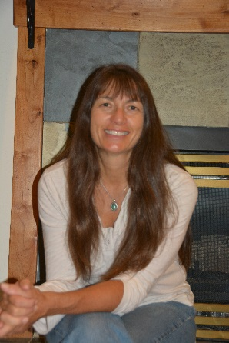Sue has worked for Outward Bound in many capacities over the past 24 years and is currently the Director of Client Services for COBS Professional and Group Programs. She is responsible for sales, program development, design, assessment and program delivery for her clients. She spent time honing her facilitation and technical skills in the mountains and rivers of Colorado, Utah and Alaska as well as in classrooms and conference centers around the country. Sue combines her strong facilitation and technical skills with an engaging style that brings out the best in people.

Sue works with clients and staff to deliver customized, high impact, results focused programs using experiential education and adventure based learning methods. She is qualified in Myers-Briggs Type Indicator and enjoys delivering this and other assessments and models to the groups she works with. Some of her clients include the Boston Consulting Group, Stanford University Graduate School of Business, Microsoft, DMCLF, Boeing Corporation, Denver Community Leadership Forum, El Pomar Foundation, JP Morgan, 5280 Magazine, Vail Resorts and Nestle Waters.

She grew up in Wisconsin and attended the University of Wisconsin-Stevens Point. Since moving to Colorado over 30 years ago, she has been involved with Professional Ski Patrolling in Colorado and was the Ski Patrol Director at 2 different resorts. She currently works part time at Beaver Creek, CO as a patroller.

She is very involved in her community, volunteering with a number of non-profit organizations, as well as at her children’s schools and soccer team. Sue and her husband have two daughters who join them skiing, backpacking, rafting, gardening, mountain biking, and cooking in their free time near their home in Eagle, CO.

**Ellen Winiarczyk**

Colorado Outward Bound School

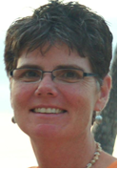Ellen Winiarczyk [pronounced win-ar’-zic) joined the COBS Professional team in 2006 and has worked as a field instructor, facilitator and program manager. As a young Outward Bound field instructor and Course Director in the 1980s she led youth and adult leadership courses and women’s courses in mountain, desert and high altitude environments across North America.

She has extensive experience developing teams and leadership skills with clients including Boeing, Vail Resorts, JPMorgan Chase, Kaiser Permanente, GroundFloor Media, Denver Metro Chamber of Commerce, American Red Cross and others.

Ellen is informed by her background as a teacher, coach and athletic director in K-12 schools in New Hampshire, 10 years as a government grants manager and education director, and 15 years of strategic planning and leadership consulting with national nonprofits, corporations and government agencies. Currently she coaches public school principals and is a doctoral student in Educational Leadership and Policy Studies at the Morgridge College of Education at the University of Denver.

Ellen is married, has two cats and loves high altitude climbs, skiing and riding her bicycle all over Denver, CO.

**Jill Lawrence**

*Outward Bound Facilitator*

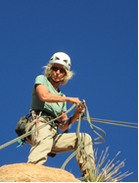

Jill has worked for Outward Bound in many capacities for more than 20 years. She started in 1994 as a field instructor, became a Course Director, Staffing Director and eventually a Program Director for both Mountain Programs in Colorado and the Urban Center in Denver.

Jill’s back ground is in Education, as a teacher in the UK. Eventually, she found the experiential approach of Outward Bound was a good fit for combining her love of the outdoors with her enthusiasm for teaching. With her sense of humor, knowing when to push participants and when to let up, her excellent facilitation and technical skills, and her fun personality, Jill excels at working with a variety of different groups, especially adults.

Jill has worked with many Outward Bound clients over the years, including the Boston Consulting Group, Stanford University Graduate School of Business, Microsoft, DMCLF, Boeing Corporation, Denver Community Leadership Forum, Lake County Government, El Pomar Foundation, and Vail Resorts, among others.

Even after 40+ years of being an avid climber, it is still Jill’s favorite day off activity. She also enjoys back packing trips in Colorado and Utah and riding her bicycle. Jill lives in Boulder Colorado with her dog Millie.

**Paul Duba, M.P.A**

*Outward Bound Facilitator*

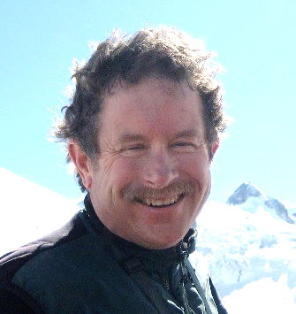Paul trains, facilitates and coaches for exceptional performance at the intersection of leadership and teamwork. He works with leaders and teams, helping them explore the behaviors that serve to align and focus their efforts in striving toward a common purpose. Paul’s teaching is outcomes-oriented, using experiential methods to lead participants to a better understanding of themselves, the interpersonal skills necessary for teamwork, and the role that leadership plays in helping teams succeed in the face of uncertainty and change. He has worked for the Colorado Outward Bound School for more than 30 years, leading adults and young adults through the wilderness of Colorado, Alaska, Utah and many other wild, wonderful places.

Paul holds a Master of Public Administration from the University of Colorado at Denver and is a trained coach through the Newfield Network, an accredited program of the International Coach Federation. With over 15 years as a trainer for high performance leadership, Paul’s work includes facilitation with the American Leadership Forum, Denver Community Leadership Forum, Denver Metro Chamber Leadership Foundation, and El Pomar Foundation Fellowship. His organizational clients include leaders from financial services (ALPS, BCG), manufacturing (C. F. Martin Guitar Co.), resort services (Vail Resorts), lodging (Stonebridge) and veterans groups (Soldiers to Summits). Paul has worked extensively in the public sector as executive director for Gunnison County’s Adult Literacy Program, Western State Colorado University’s Service Learning Program, and as an elected member of the Gunnison City Council.

Paul lives in Gunnison, one of Colorado’s great mountain towns. In his spare time, he is a volunteer with local immigrant advocacy and the Gunnison Valley Community Foundation. He is also a devoted high altitude gardener, skier, guitar player, and swing dancer.

**Kim Reynolds**

*Outward Bound Facilitator*

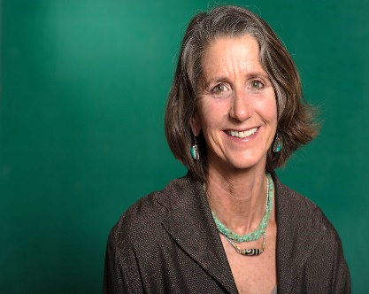

Kim has worked with Outward Bound since 1981 as an Instructor, Course Director, Program Director and currently, a Program Manager and Lead Facilitator for COBS Professional. She has lead courses in Nepal, Alaska, Oregon, Washington, Colorado and Utah that incorporate teambuilding, leadership, management and technical skills training.

Kim graduated from Prescott College in 1984 with a degree in Wilderness Interpretation and Outdoor Leadership. She is a Certified Life Coach CPCC with additional training in Organization & Relationship Coaching Systems and Neuroscience. She is passionate about inspiring people to face fears and expand self-limiting perceptions through challenge and mental discipline.

Kim has an adventurous spirit and is an avid mountaineer, ice climber, backcountry skier and whitewater kayaker. She has traveled the world guiding trips and exploring wild places. She just recently moved from Ridgway, Colorado to Denver and is adjusting to city life quite well, always looking for new growth opportunities in her life.

**Wendy Forrester**

*Outward Bound Facilitator*

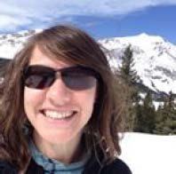

Wendy Forrester has been facilitating groups through outdoor education and guiding, academic instruction, and ropes courses since 2003. She has over 5,000 hours working with groups from corporations to schools to recovery programs. Her love of pairing people and the outdoors began when she was a field instructor for the Colorado Outward Bound School. Now she continues to foster others’ leadership capabilities in the corporate and higher education sectors through self-awareness, communication, and compassion.

She has had the pleasure of working with such organizations as New Belgium Brewing, OtterBox, El Pomar Foundation, Poudre Valley Health Systems, Leadership Northern Colorado, Tomar Pharmaceuticals, Larimer County, Colorado State University, Campus Crusade, Denver University, Antarctica field researchers, as well as numerous staff from Denver, Big Thompson, and Poudre School Districts. Wendy has also been increasing her opportunities to mentor and train other instructors and facilitators as a way to utilize her skill of teaching adults.

Outside of “work,” Wendy is passionate about her community, serving through her local church and public programs, as well as rock climbing with friends and running with her dog. When she's not doing that, she facilitates two rambunctious boys at home.

**Karin Pocock**

*Outward Bound Facilitator*

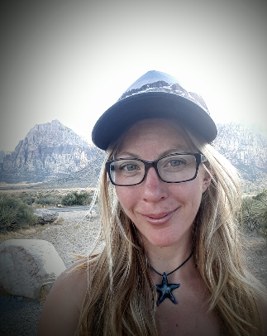Karin is a year round outdoor industry professional. She currently splits her time between outdoor education, guiding and avalanche forecasting. Karin has worked for Outward Bound for 14 years as an Instructor, Course Director, Staff Trainer, and Associate Program Director. She has worked for Outward Bound Schools in California, Colorado, British Columbia, Alberta, and Ontario.

Karin is passionate about the pursuit of excellence in both the facilitative and technical sides of outdoor education. In addition to years spent developing as a facilitator with Outward Bound schools in North America, she has also pursued technical certification and is a professional member of the American Mountain Guides Association trained in rock, alpine and ski disciplines. Very much still an active student, Karin is currently pursuing international certification as a Mountain Guide through the American Mountain Guides Association training and certification process.

Karin currently splits her time between Colorado and Western Canada. In the summer’s you can find her working in Leadville, CO as a Course Director and Staff Trainer for the Colorado Outward Bound School. In the winter, Karin is currently employed as an Avalanche Forecaster in southern Alberta. Karin is a professional member of the Canadian Avalanche Association (CAA) and holds the designation of Avalanche Forecaster through technical training from this organization.

Karin was formally education in tourism and business management as well as paramedicine. She has worked as a high school teacher at a private independent school as a well as a private industry paramedic for several years in addition to outdoor industry work.

When not working Karin can be found rock climbing throughout the desert southwest. While rock climbing is also something Karin does professionally for work; the warm, windswept cliffs of the desert are where her heart lies whether for work or play.